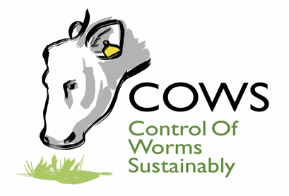
Press Release from COWS

10 June 2020

New guidance from COWS: Integrated parasite control on cattle farms

The Control of Worms Sustainably in cattle (COWS) group has published the final chapter in its updated Guide, bringing together key technical messages from other new chapters on roundworms, lungworm, liver and rumen fluke and ectoparasites.

The Guide sits at the core of the COWS initiative – outlining the latest science relating to parasite control in cattle. All five chapters sit on the COWS website (www.cattleparasites.org.uk) and are freely available for vets, registered animal medicines advisers (RAMAs)/SQPs and cattle farmers.

“We were keen to show how the principles and treatments outlined in the parasite-specific chapters can be applied to some common farming scenarios,” says Rebecca Small, AHDB animal health and welfare scientist and co-ordinator for COWS.

“While the precise situation on every farm will be different, this last chapter offers an idea of how the different strategies for individual parasites can work together. In many cases, there is often a risk of one or more being a problem within the cattle enterprises on the farm.”

The five scenarios include a beef suckler farm with calves born in spring, a beef suckler farm with calves born in autumn, an autumn or spring calving suckler herd with animals bought-in, dairy herds grazing all summer with weaned calves and youngstock turned on the same farm, and finally dairy herds with weaned calves and youngstock kept at a separate unit.

For each scenario a control plan for the grazing season is outlined, including possible tests that can be carried out, with a summary of the key points at the end. The scenarios have been developed and written by leading cattle parasite academics; Professor Diana Williams and Dr John Graham Brown from the University of Liverpool and Professor Eric Morgan of Queen’s University, Belfast.

“Working out an action plan to protect and treat a herd of cattle can be complex,” Ms Small admits.

“The COWS team now feels the new Guide should be the first place anyone goes with queries or questions about cattle parasites. However, in most cases, farmers should still seek advice from their vet and animal health adviser about the specific parasites affecting their animals.”

[Ends]

Images:
Front page of the Integrated parasite control on cattle farms chapter
Scenario 3 page from Integrated parasite control on cattle farms

For more information contact:

Rebecca Small,
COWS co-ordinator
AHDB Beef and Lamb
Mobile: 07443 254093
Email: Rebecca.small@ahdb.org.uk

Issued by:
Sara Gregson
COWS Communications
Tel: 01799 530934
Email: sara@saragregson.co.uk

