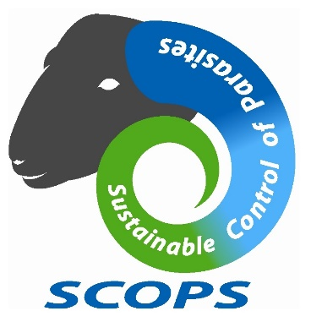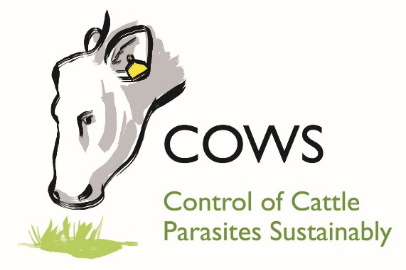
SUSTAINABLE CONTROL OF PARASITES IN SHEEP (SCOPS) and CONTROL OF CATTLE PARASITES SUSTAINABLY (COWS)
JOINT PRESS RELEASE
Tuesday 16th October 2018 – no embargo

Latest liver fluke warning urges sheep and cattle farmers to ‘keep on your guard’

The Sustainable Control of Parasites in Sheep (SCOPS) and Control of Cattle Parasites Sustainably (COWS) groups are urging sheep and cattle farmers not to take their eyes off the ball when it comes to the liver fluke threat risk this autumn.

While liver fluke burdens on pasture are expected to be much lower than last season, experts are warning it is dangerous to assume that applies to all farms, all areas on a farm, or that levels will remain low as the autumn progresses.

Speaking on behalf of SCOPS, sheep consultant Lesley Stubbings says: “So far, reports from around the UK support this advice. Experts are warning that farmers must keep on their guard and are predicting that, due to changes in weather patterns, acute liver fluke cases may occur later than normal.”

Advice from SCOPS and COWS:-
- Don’t get caught out by treating too early. Monitor to determine the need and timing of treatments (see list of tools below).
- In lower risk situations, consider treating sheep with closantel or nitroxynil rather than triclabendazole.
- Worms (including haemonchus, which can produce signs similar to liver fluke disease) may be the problem, particularly in lambs. Keep in mind that haemonchus is also a risk for ewes.
- Investigate losses. A post mortem is still the best way to establish whether liver fluke is present.
- Monitor abattoir returns carefully for evidence of liver fluke.

Diana Williams, Liverpool University and a member of COWS, says: “Snail numbers on farms were high at the beginning of the season. While the hot dry weather caused numbers to drop during July and August in most locations, this was not the case everywhere, with high numbers of snails observed in some persistently wet habitats. This means that although overall numbers of snails are likely to be lower, specific areas of pasture may still present a high risk of fluke.”

John Graham-Brown of NADIS agrees: “The NADIS forecast anticipated that the hot dry weather over the summer months would have reduced snail activity, with lower infection levels of fluke on pasture as a result. Our predictions suggest the peak fluke season may be later and shorter this year.”

On many farms where animals would normally be routinely treated, testing not only aids the timing and choice of treatments but also helps to avoid unnecessary treatments of animals. SCOPS and COWS encourage producers to consider the range of tools available to them:-
- Faecal egg count (FEC) testing. To indicate if adult fluke are present in the animal.
- Coproantigen testing. Thought to detect the presence of fluke a little earlier (2-3 weeks in sheep) than a fluke FEC test.
- Blood (ELISA) testing. Detects antibodies produced when sheep and cattle are exposed to infections. These tests are most useful in animals in their first grazing season to indicate exposure to infection, but could be useful this year on farms where no exposure to fluke has been assumed because of the dry weather.
- Bulk-tank milk (ELISA) testing. To detect exposure to infection in dairy herds.
- Post mortems on dead animals.
- Abattoir returns on livers. A very useful source of information for both cattle and sheep.

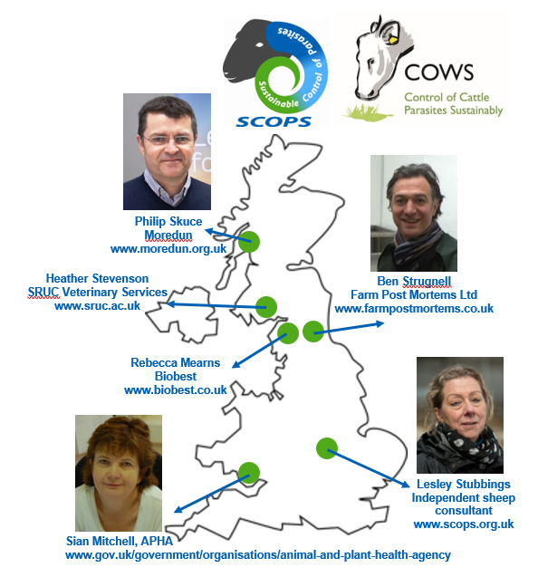
Updates from around the UK
- Heather Stevenson, SRUC Veterinary Services, based in Dumfriesshire: “We are seeing some fluke eggs in a small number of samples from lambs, which are probably from infections picked up in late spring/early summer. However, we are seeing some massive worm (roundworm, not fluke) burdens in lambs and, because the symptoms can be similar to liver fluke with some worm species, farmers must get a diagnosis. If farmers treated for fluke in September as a routine without testing and don’t do anything else until January, they could easily be caught out.”
- Philip Skuce, Moredun, on monitoring work in Argyll: “To gauge current fluke infection levels, we are faecal sampling sheep in Argyll, a notorious hotspot for fluke due to its mild, wet climate, and this should act as a good early warning system for other parts of the UK. So far, we have seen low fluke egg counts (both liver fluke and rumen fluke), indicative of a low level chronic (adult) fluke infection –but this may change and we need to keep up the surveillance.”
- Sian Mitchell, APHA, based in Cardiff: “We have not diagnosed any cases of acute fluke in England and Wales as yet. But we are detecting fluke eggs in faeces or liver damage due to fluke on post mortem examination, suggesting chronic fluke infections. We are also seeing severe roundworm infections in lambs, reinforcing the need to get a diagnosis as to cause of diarrhoea or death.”
- Ben Strugnell, Farm Post Mortems Ltd, County Durham: “I have not seen any acute cases of liver fluke yet, only live adult flukes (as a subclinical disease) in suckler cows. These could have been a source of fluke eggs throughout the season and as such a ‘safe haven’ for the parasite during the very dry conditions.”
- Rebecca Mearns, Biobest: “We carry out the coproantigen test for liver fluke in our lab and, so far, there have not been any positive tests in lambs. I urge sheep farmers not to just rush to blame trace elements for poor lamb performance, as worms are a real threat this autumn.”
- Lesley Stubbings, SCOPS: “When we get a dry year, it is even more important that each farm does its own risk assessment and carries out monitoring and testing to avoid getting caught out, because there will be huge variation between regions and farms”.

More at www.scops.org.uk and www.cattleparasites.org.uk.

Notes to editors: -
- This press release is issued by National Sheep Association (NSA) on behalf of SCOPS. For more information contact Katie James, NSA Communications Officer, on 01684 892661 or katie@nationalsheep.org.uk.
- SCOPS is an industry led group that works in the interest of the UK sheep industry. It recognises that, left unchecked, anthelmintic resistance is one of the biggest challenges to the future health and profitability of the sector. Find out more at www.scops.org.uk.
- COWS is a voluntary initiative aiming to provide the best available, evidence-based information to the beef and dairy cattle industries in relation to the sustainable control of both internal and external parasites. Find out more at www.cattleparasites.org.uk.

